San Francisco State University
Software Engineering CSC 648 - 848

Project - Ascenda
Section 06 Team 1

Alisha Sinha | Team Lead
Ian Brown | Scrum Master
Zaw Htut | Git Master
Prashrit Magar | AI Master
Geo Wong | Back-end Lead
Dong Wu Yu | Front-end Lead

Milestone 1
September 29, 2026

1. Executive Summary:
Fitness applications give users access to hundreds of exercises, workout programs, and tracking tools, yet many people still struggle to stay consistent with training. A major limitation of existing platforms and services today is that service and service environment itself is too rigid. They may not adequately account for a user’s experience, goals, available time, equipment, physical capability, or previous performance. Beginners face and additional challenge because they may not know whether a program is appropriate for them, how much training they should perform, or where required equipment is located in an unfamiliar gym. As a result, users may abandon workouts, lose confidence in their ability to complete a program, or fail to make measurable progress.
Ascenda is an adaptive fitness-training platform designed to make structured exercise programs easier to start, follow, complete. Each program provides user with an expected duration of the workout and separates exercises into core exercises, which are essential to the program’s primary goals, and accessory exercises, which provide additional support toward program goals but can be adjusted when necessary. If a user has less time than expected, Ascenda can help preserve the most important parts of the workout while allowing lower-priority exercises to be removed or substituted. This allows user to adapt the workout, and subsequently the overall program to real-life schedule or equipment constraints without losing the purpose of the training session.

Ascenda also uses fitness assessments and workout history to give users a measurable starting point and a clearer understanding of their progress. Assessments can help determine the appropriate training volume and progression, while completed workouts, performance history, and program changes are preserved over time. The program can provide a more personalized training experience as the user develops instead of treating every workout as an isolated activity or frequent feedback from a trainer. Ascenda also aims to make gyms easier to navigate for users unfamiliar via Niantic Spatial’s Sites API, organizing participating gyms into easy-to-navigate 3D spaces and floorplans into easily identifiable zones, showing users where equipment required for a given workout is located. This can reduce time spent navigating gyms space on a tight schedule and relieve new gym goers from being overwhelmed.
Ascenda’s key advantage is the combination of structured adaptability, measurable fitness assessments, persistent progress tracking, and gym navigation in a single platform. Ascenda is explicitly designed to be friendly to users of all levels and to help users successfully complete long-term training commitments, accommodating, the barriers and challenges that commonly interrupt consistency. This foundation allows Ascenda to grow and scale from a personal training tool, into a broader platform connecting, users, trainers, and participating gyms.

Ascenda is being developed by our student team, using feedback collected form users of different ages, fitness backgrounds, goals, schedules, and training environments. By grounding the product in problems real users experience, out team aims to build an innovative and practical fitness platform that improves training consistency, makes progress and programming easier to understand, and lowers the barriers that prevent people from commiting to a healthier and active lifestyle.

2. Personas and User stories:
Persona ID #1
Behavior: Inconsistently exercises or is beginning/returning to regular exercise. Prefers organized workouts and clear instructions rather than having to design a program independently. May exercise at home or at a gym depending on convenience.

Interests:
- Improving general health and appearance
- Building strength and muscle
- Learning proper exercise technique
- Creating a consistent exercise routine
- Seeing measurable improvement

Skills: Low to moderate fitness knowledge. May recognize common exercises but doesn’t necessarily understand how to build a balanced program, determine appropriate training volume, or evaluate progress.

Pain Points:
- Doesn’t always know what exercise to perform
- Can get overwhelmed by complicated fitness applications
- May stop training when workouts feel too difficult or confusing
- Needs greater accountability and direction
- May be unfamiliar with gym equipment or where equipment is located
- Wants the application to be simple and easy to follow
This persona combines findings from beginner and early developing users who preferred organized workout routines, simple interfaces, checkpoints, and guidance. One beginner specifically reported becoming overwhelmed by feature-heavy fitness applications, while another valued trainer guidance.

Persona ID #2
Behavior: Wants to exercise consistently but has work, school, family, or a combination in addition to other responsibilities that can unexpectedly reduce available workout time. This user may already understand basic exercise but needs fitness to fit around a changing schedule.

Interests:
- Efficient workouts
- Knowing how long a workout will take
- Maintaining consistency
- Strength, appearance, health, or general fitness
- Being able to modify a session without abandoning it or without significant effor to modify

Skills: Beginner through advanced. Usually capable of following a structured workout but may not know which portions of the workout are acceptable to remove when time becomes limited.

Pain Points:
- Work, school, etc. interferes with planned workouts
- May skip an entire workout when there doesn’t seem to be enough time to commit
- Fixed-length workouts in a program can be difficult to maintain
- Commuting to a gym can make exercise less practical

Multiple interview participants identified time as a major barrier. Circumstances varied form unpredictable professional responsibilities to schoolwork and commuting. But the common problem was fitting structured exercise into limited time and volatile schedules.

Persona ID #3
Behavior: Exercises to maintain independence, mobility, health, or long-term physical capability. The user may be experienced or inexperienced, but injuries, joint pain, mobility restrictions, recovery from surgery, or other physical changes affect what they can comfortably perform.

Interests:
- Maintaining strength and mobility
- Long-term health
- Exercise modifications
- Home workouts
- Gradual measurable progress
- Maintaining independence

Skills: Varies significantly. Some user may have years of experience, while other may primarily know exercises previously provided by a physical therapist or trainer.

Pain Points:
- Physical ability may change form day to day
- Certain exercises may cause pain or be inappropriate
- Standard programs may assume unrestricted mobility
- Progress may be slower than expected
- Users may struggle with motivation when physical therapy appointments or external accountability end

The interviews show that physical limitations are not limited to beginners. Experienced users reported joint pain and mobility restrictions, while another participant recovering from knee surgery wanted to continue rebuilding strength and range of motion after completing physical therapy. This also compliments the older demographic that fit this description in addition to other age groups.

User Stories
- Getting Started and Selecting a Program
  - Persona 1 - HIGH
    - As a Beginner needing guidance, I want to select a program based on my goals and current ability so I know what I should be working toward
  - Personas 1, 3 - HIGH
    - As a user starting a program, I want to assess my current fitness so that I can establish a starting point and understand my current abilities
  - Personas 1, 2 - HIGH
    - As a user, I want to see the expected duration of a program and individual workouts before starting so I can determine whether it fits my available time.
- Following and Completing Workouts
  - Persona 1 - HIGH
    - As a beginner, I want my workout presented in a clear sequence so that I can progress throught he session without having to decide what to do next.
  - Personas 1, 3 - HIGH
    - As a user unfamiliar with an exercise, I want access to guidance on proper exercise form so that I can better understand how to perform it.
  - Personas 1, 2 - MEDIUM
    - As a user completing a workout, I want to record the exercises, repetitions, or other work I completed so that my workout becomes part of my training history.
  - Persona 1 - HIGH
    - As a user exercising in an unfamiliar gym, I want to identify where the equipment required for my workout is located so that I spend less time searching for it. Especially when gyms reorganize their equipment layout.
- Adapting a Workout
  - Persona 2 - HIGH
    - As a user with limited time, I want to shorten a workout while keeping its most important exercises so that I can still complete meaningful training.
  - Persona 2 - HIGH
    - As a user, I want to substitute and exercise when its equipment is unavailable so that I can continue my workout instead of waiting or abandoning the exercise.
  - Persona 3 - HIGH
    - As a user with physical limitation, I want to choose an appropriate variation or alternative exercise so that I can continue participating at my current ability level.
- Tracking Progress
  - Personas 1, 3 - HIGH
    - As a user, I want to view my previous workout performance so that I can compare my current performance with earlier sessions
  - Personas 1, 3 - HIGH
    - As a user following a program, I want to repeat fitness assessments at appropriate points so that I can measure whether my abilities have improved.
  - Personas 1, 2 - MEDIUM
    - As a user, I want to see how much of my program I have completed so that I can understand my progress and remain consistent
  - Unique entry - MEDIUM
    - As an experienced trainee, I want workout tracking to remain optional and unobtrusive to the experience so that I can use the program without being required to record information I don’t find useful to myself.
    - **Interview results support this unique entry because tracking preferences varied strongly. Some participant valued tracking strongly, particularly newer users, while experience users (5+ years) sometimes tracked little or nothing.
- Maintaining a Sustainable Routine
  - Personas 1, 2 - MEDIUM
    - As a user with a dynamic weekly schedule, I want to organize training around my available schedule so that I can exercise more consistently.
  - Persona 1 - MEDIUM
    - As a developing user, I want visible milestones or checkpoints so that I can recognize progress and remain motivated.
  - Persona 3 - MEDIUM
    - As a user whose physical capability changes over time, I want my workout options to accommodate those changes so that I can continue training rather than abandoning the program.
  - Persona 1 - LOW
    - As a user interested in nutrition, I want simple fitness-related nutrition guidance so that I can better support my training without needing to follow a highly restrictive diet.
Priority Legend:
HIGH Priority - Ascenda’s primary value: helping users select appropriate programs, complete structured workouts, adapt workouts to real-world constraints, and measure progress.
MEDIUM Priority - likely to improve retention, personalization, navigation, and long-term usability but not essential to the core experience of Ascenda.
LOW Priority - useful area for future expansion but presently outside that primary scope of Ascenda’s purpose.

3.Data Definitions

Below are the core terms and concepts that make up Ascenda. We've tried to keep these definitions grounded in how a real user would actually think about their training, rather than how the data happens to be stored. Going forward, these are the names we'll stick to across requirements, screens, the database, and the code itself, so everyone on the team (and anyone reading this later) is talking about the same thing.
Two findings from our interviews shaped this model more than anything else. First, beginners told us that feature-heavy fitness apps are overwhelming, and that what they actually want is a clear, ordered sequence of what to do next rather than a pile of options. Second, nearly everyone we talked to, regardless of experience level, described real life getting in the way of a fixed workout plan, whether that was a packed schedule, an unavailable machine, or a physical limitation that changed day to day. The Core Exercise / Accessory Exercise split, Exercise Modification, and Exercise Substitution all exist specifically to answer that second problem: they let a session flex around a person's real circumstances without losing what the workout was supposed to accomplish in the first place.
User
Anyone using Ascenda to work through a fitness program like logging workouts, tracking how they're doing, and adjusting their training as life gets in the way. A User can see their own profile, the programs they're on, their workout history, past assessments, and whatever preferences they've set.
Administrator
Someone on the Ascenda side who keeps the shared parts of the app up to date like the exercise library, the list of supported equipment, and which gyms are registered. Administrators don't get a backstage pass into a User's personal workout history, though; that stays private.
User Profile
The set of preferences and personal details that shape how Ascenda trains a particular person. This can include things like how experienced they are, what they're training for, where they usually work out, what equipment they have access to, how long they like sessions to run, how often they can train, and any physical limitations they've mentioned.
Fitness Goal
Whatever outcome someone actually wants out of their training. That might be strength, better cardio, muscular endurance, flexibility, mobility, general health, how they look, or performance in a specific sport. One thing we learned from talking to real users: fitness goals are rarely just "lose weight" or "build muscle," people's reasons are a lot more varied than that, and the app should reflect it.
Fitness Assessment
A short, structured check-in used to figure out where someone's fitness actually stands, either at the start of a program or partway through it. It gives us a concrete number (or set of numbers) to compare against later, so progress isn't just a feeling.
Training Program
The overall plan is a series of Workout Sessions laid out over time, aimed at one or more Fitness Goals. A Training Program can carry an expected length, a schedule, checkpoints, and a sense of how it's supposed to progress.
Workout Session
One single workout within a Training Program. It's made up of exercises, has a rough expected duration, and includes whatever guidance helps the user get through it.
Exercise
A specific movement or activity that can show up in a Workout Session. Each Exercise can carry its own purpose, the equipment it needs, instructions, what it's meant to train, and any easier/harder variations or swaps.
Core Exercise
An Exercise central to what a Workout Session is actually trying to accomplish. If a session ever needs to get shorter, Core Exercises are the last thing we'd cut.
Accessory Exercise
An Exercise that adds value but isn't load-bearing for the session's main purpose. These are the first candidates to drop when someone's running short on time.
Exercise Modification
A version of an Exercise adjusted to a different difficulty or physical ability level. This one matters more than it might sound — our interviews showed that physical limitations affect beginners and experienced lifters alike, not just one or the other.
Exercise Substitution
A stand-in Exercise that keeps the same general purpose when the original one doesn't work, usually because the equipment isn't available, the setting changed, or the User simply can't do that movement right now. Equipment-driven swaps came up independently across multiple interviews, so this was clearly worth building for.
Program Customization
A lasting change to a User's own Training Program, adjusting its difficulty or frequency based on how a recent assessment or workout went, consistently swapping one exercise for another going forward, or reshaping the schedule to fit their week. This is different from a one-off Exercise Substitution made in the middle of a single Workout Session: a Program Customization is remembered, and it's expected to keep the program's original structure and purpose intact rather than replacing it.
Equipment
A specific item or category of gear that an Exercise might need, or might just benefit from. Dumbbells, barbells, resistance bands, cable machines, benches, and cardio machines all fall under this.
Gym
A real, physical place to work out that Ascenda can represent internally, mainly so Users can figure out where their Equipment actually is.
Training Zone
A distinct area inside a Gym associated with a particular kind of equipment or activity, for instance, think the free-weight section, the cable machines, the cardio floor, or the stretching area.
Physical Capability Constraint
A limitation a User tells us about that might affect which Exercises or Exercise Modifications make sense for them right now. To be clear, this describes what someone's body can currently handle in training, it's not a medical diagnosis, and we're not treating it as one.
Workout Record
Proof that a Workout Session actually happened. It can capture the date, which exercises got done versus skipped or swapped, and whatever Performance Entries were logged along the way.
Performance Entry
A single piece of data about how someone actually performed on an Exercise, reps, weight, time, distance, or just whether they finished it, depending on what that Exercise is.
Program Progress
A rollup of how far along someone is in their Training Program, sessions completed, assessment results, milestones hit, and other signs of whether they're staying consistent.
Workout History
Everything a User has completed so far, all in one place, so they can look back and see how current training stacks up against what they were doing before.
Availability
How much time someone actually has to work out right now, which may not match what the Workout Session was originally planned for. This is what a User leans on when deciding whether today's session needs to be trimmed down.

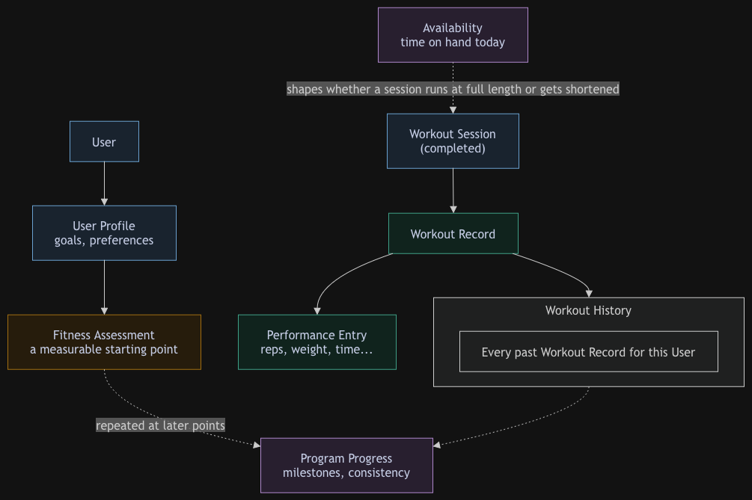

Figure 1: This shows what happens after a workout is completed. A finished Workout Session becomes a Workout Record, which logs individual Performance Entries and gets added to the User's Workout History. Fitness Assessments are repeated over time to measure real improvement, and together with Workout History they roll up into overall Program Progress, so progress is tracked cumulatively, not workout by workout. Availability is shown separately because it affects whether a session runs full-length or gets shortened before it's even logged.

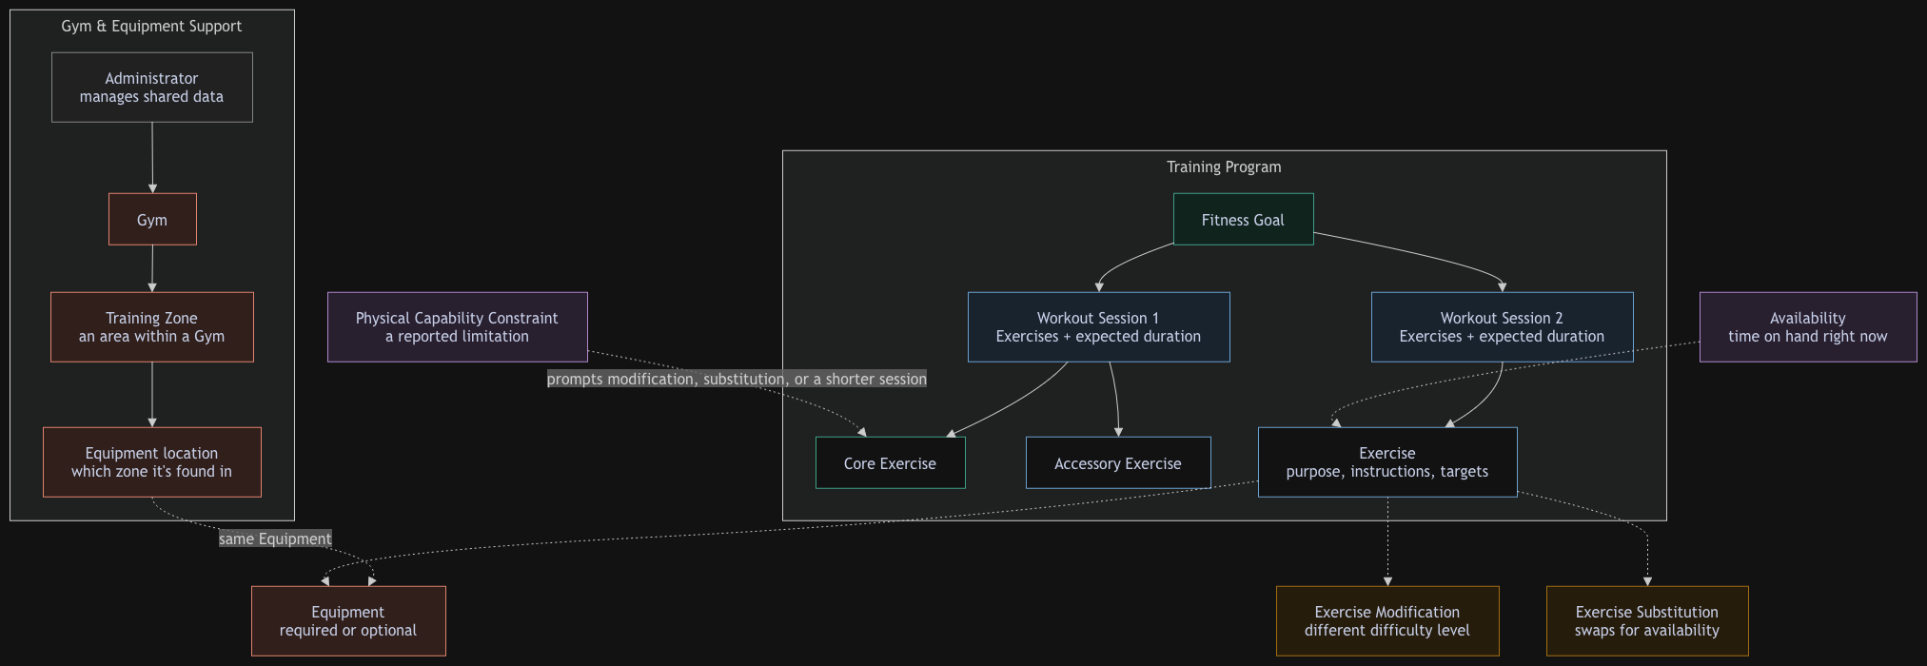

Figure 2: This shows how one Training Program is put together, a Fitness Goal drives a series of Workout Sessions, each built from Core Exercises (which never get cut) and Accessory Exercises (which can). When a Physical Capability Constraint or limited Availability gets in the way, the app responds with a Modification, a Substitution, or a swapped piece of Equipment instead of breaking the workout entirely. The bottom section shows how Gyms and their equipment stay organized, an Administrator registers a Gym, maps it into Training Zones, and that's how the app knows where a given piece of Equipment actually is.

4.Initial List of Functional Requirements

Account
ID | Title | Description | Priority
R1 | Registration/Login | Create account and log in | Priority 1
R2 | User Profile | Set goals, experience level, available equipment, schedule | Priority 1

Programs / Workouts
R3 | Exercises | Stores exercises with demonstration and required equipment | Priority 1
R4 | Assessment | Create an initial experience level assessment | Priority 1
R5 | Exercise Catalog | Can browse exercises or pre-made programs depending on experience level | Priority 1
R6 | Workout Duration | Expected duration calculated from exercises | Priority 1
R7 | Program Recommendation (Using AI) | Suggests programs to match user’s assessment and goals | Priority 2-3

Progress Tracking
R8 | Logging | User can log their sets/reps after each exercise | Priority 1-2
R9 | Workout History | Show current and past workouts | Priority 1-2
R10 | Workout Tracking | Can display performance trends | Priority 2-3
R11 | Workout Adjustment | Allows user to adjust workout difficulty or frequency depending on assessment/performance | Priority 2-3

Using Niantic
R12 | Gym Scanning | Allows user to scan available equipment | Priority 2-3
R13 | Equipment Details | After scanning, shows users available workouts with scanned equipment | Priority 2-3
R14

5.List of non-functional requirements

- Performance - The application shall load pages and display workout information within 4 seconds under normal network conditions.
- Storage Space - The application shall provide sufficient storage for user profiles, fitness assessments, workout history, programs, and other required application data.
- Usability - The application shall provide a clear and easy to use interface that allows users to easily navigate workouts, track progress, view assessments, and determine the gym equipment in the area.
- Security - The application shall protect user account information, fitness assessments, workout history, and other personal data from unauthorized access.
- Data Storage - The application shall reliably store user profiles, completed workouts, assessment results, progress history, and program changes so that user information is available across future sessions.
- Availability - The application shall be available to users through the deployed web application under normal operating conditions, excluding planned maintenance and third party service outages.
- Fault Tolerance - The application shall continue providing core functionality when noncritical services, such as gym navigation are down.
- Expected Users - The application shall support at least 100 concurrent users performing normal activities without significant performance degradation.

6. Competitive Analysis:

Interview participants reported experience with products including BODi, Ladder, BetterMe, MyFitnessPal, Fitbit, MyNetDiary, trainer-supported applications, and other online fitness services. Their experiences show that existing applications already provide useful workout libraries, tracking, coaching, and structured programs, but users continue to encounter problems involving rigidity, equipment availability, changing schedules, physical limitations, and excessive complexity.

For the initial market comparison, Ascenda is compared with Fitbod, JEFIT, and Nike Training Club, which represent several current approaches to digital fitness.

Key Feature | Fitbod | JEFIT | Nike Training Club | Our Fitness App
Beginner-focused experience | Supports beginner experience levels | Beginner plans + guidance | Beginner-friendly guided workouts | Designed around helping beginners know exactly where to start
Initial assessment | Onboarding based on goals, experience & equipment | Setup/plans based on user preferences | Users choose workouts/programs | Starting assessment used to establish the user’s current ability and starting point
Personalized workouts | Automatically generated/adaptive workouts | Custom plans + adaptive training | Guided programs | Personalized program based on assessment, goals, schedule & available time
Time-based workouts | User selects workout duration | Workouts can be planned/customized | Workouts of varying lengths | User tells us exactly how much time they have and receives a workout designed around it
Adaptive progression | Adjusts based on workout history, performance & recovery | Tracks performance and offers adaptive plans | Structured multi-week programs | Continuously adjusts difficulty based on user performance and feedback
Beginner direction / simplicity | Large exercise library + recommendations | Extensive planning/tracking tools | Trainer-led instruction | Simple guidance explaining what to do, why they’re doing it, and what comes next

Our planned fitness application will differentiate itself by focusing on beginner accessibility, personalized assessment, and time-efficient adaptive training. Rather than expecting users to already understand exercises, workout splits, sets, reps, or appropriate starting weights, our application will guide users from the beginning of their fitness journey. New users will complete an initial assessment that helps establish their current ability, goals, available equipment, and workout availability so that the application can create an appropriate starting program. Users will also be able to specify how much time they have available for a workout, allowing the application to generate sessions that fit their schedules. As users complete workouts and provide feedback, the program can adapt their future workouts and progression. The goal is to provide beginners with both personalization and direction, reducing the confusion of figuring out what to do at the gym while helping users make consistent progress.

7. High-level System Requirements

Approved Software Components, Platforms, and Tools
Component / Category | Approved Technology / Tool
Cloud /Hosting Platform | Vercel
Front-End Framework | Next.js 16.x
Front-End Library | React 19.x
Back-End Language | Python 3.14.x
Back-End Framework / Web API | FastAPI
API Architecture | RESTful Web API
Database Platform | Supabase
Database Management System | PostgreSQL
IDE / Code Editor | Visual Studio Code
Version Control | Git / GitHub
Supported Browsers | Google Chrome, Mozilla Firefox, Microsoft Edge, and Apple Safari
Spatial / 3D Technology | Niantic Spatial, if incorporated into Ascenda
Development / Project Tools | Notion, Claude, ChatGPT, Gemini, and Canva
Additional External Libraries / APIs / SDKs | Any additional third-party libraries, APIs, SDKs, such as Three.js and Niantic Spatial SDK (NSDK) for Unity or open-source software used by Ascenda will be added to this approved list.

8.Team:

# | Name | Role
1 | Alisha Sinha | Team Lead
2 | Ian Brown | Scrum Master
3 | Zaw Htut | Git Master
4 | Prashrit Magar | AI Master
5 | Geo Wong | Back-end Lead
6 | Dong Wu Yu | Front-end Lead

One-Month Technology Study Plan
Ascenda's stack has several pieces no one on the team has production experience with yet: Next.js/React on the frontend, FastAPI/Python on the backend, Supabase/PostgreSQL for data, Docker + GitHub Actions + Vercel for the deployment pipeline, and Niantic Spatial (Sites API + Capture/Scaniverse) for gym navigation. Below is a 4-week plan, starting from the week M1 is announced, split by owner so nothing falls through the cracks and everyone can speak to their piece when M1 is graded.
Peter — Frontend Lead: Next.js 16 / React 19
- Goal: Be able to build and route Ascenda's pages, manage component state, and call the FastAPI backend, without needing help for routine screens.
- Week 1: Complete the official Next.js "App Router" tutorial; build a throwaway 3-page app (home, login, dashboard) to get comfortable with file-based routing and server vs. client components.
- Week 2: Learn React 19 fundamentals (hooks, state, forms) by rebuilding one Ascenda screen from the wireframes (e.g., the workout session view) with mock data.
- Week 3: Connect that screen to a real FastAPI endpoint Geo has stood up; learn fetch/use patterns for calling a REST API from Next.js.
- Week 4: Deploy the working prototype to Vercel with Zaw; write a short internal doc on component/folder conventions so the rest of the frontend work stays consistent.
Geo — Backend Lead: FastAPI, Python 3.14, Supabase/PostgreSQL
- Goal: Stand up a working REST API backed by Postgres that the frontend can actually call, and understand how the Niantic Sites API will plug into it.
- Week 1: FastAPI's official tutorial end-to-end; build one CRUD endpoint (e.g., Exercise) with request/response models (Pydantic).
- Week 2: Set up a Supabase project, connect it via PostgreSQL, and model the core tables from Section 3 (User, Training Program, Workout Session, Exercise, Workout Record).
- Week 3: Read Niantic Spatial's developer docs for the Sites API (Organization → Site → Asset hierarchy, Bearer token auth); write one script that authenticates and pulls back a sample Site's data, just to prove the connection works server-side.
- Week 4: Wire up one full path end-to-end (frontend → FastAPI → Supabase) with Peter; document the API contract for the rest of the team.
Zaw — GitHub Master: Git workflow, Docker, CI/CD, Vercel
- Goal: Have a branching strategy, PR process, and deployment pipeline the whole team can actually follow without breaking main.
- Week 1: Set up the GitHub repo structure, branch protection rules, and a PR template; write a one-page "how we work in Git" doc for the team (branch naming, commit style, review requirement).
- Week 2: Learn Docker basics (image, container, Dockerfile) and containerize the FastAPI backend so it runs identically on every machine.
- Week 3: Set up a GitHub Actions workflow that runs lint/tests on every PR automatically.
- Week 4: Connect the repo to Vercel for automatic frontend deploys on merge to main; do a dry run of the full pipeline (branch → PR → CI → merge → deploy) with the team.
Prashrit — AI Master: Program Recommendation logic + Niantic Capture/Scaniverse
- Goal: Have a working first-pass approach for the AI-driven Program Recommendation feature (R7), and a hands-on understanding of what Niantic's Capture tooling can and can't do for Ascenda's gym-navigation feature.
- Week 1: Research how existing apps (Fitbod, JEFIT) structure adaptive recommendation logic; decide whether Ascenda's first version should be a simple rules-based recommender (goals + experience level → program template) or something more ML-driven — rules-based is realistic for a first milestone.
- Week 2: Prototype that rules-based recommender in Python as a standalone script using sample User Profile data, independent of the backend.
- Week 3: Install Scaniverse, capture a real small space (a room or a section of a gym if accessible), and walk through Niantic's Capture-to-Sites-API pipeline hands-on, to understand what an Administrator would actually have to do to register a Gym.
- Week 4: Write up findings on both fronts — a short spec for how the recommender plugs into Training Program creation, and a realistic assessment of the effort needed to onboard a real gym via Niantic — to hand off to Geo for backend integration.
Ian — Scrum Master: Agile/Scrum fundamentals + sprint tracking
- Goal: Run sprint planning, standups, and backlog grooming so the team stays coordinated and blockers surface early, without needing outside help to keep things on track.
- Week 1: Learn core Scrum concepts (sprints, backlog, standups, retrospectives) through a short course; set up a shared backlog tool (GitHub Projects, coordinating with Z since the repo's already being set up there) seeded with tasks pulled from the Functional/Non-Functional Requirements.
- Week 2: Run the first real sprint planning session, breaking the deliverables into sprint-sized tasks assigned across Peter, Geo, Zaw, and Prashrit; start weekly standups.
- Week 3: Run a mid-sprint check-in, re-balance the backlog based on what everyone reports (especially if Niantic work is running slower than expected), and start informally tracking whether the team is on pace for the M2 deadline.
- Week 4: Run a retrospective on the first month of what worked, what didn't and use it to set the sprint cadence going forward; confirm every task from this study plan has a clear owner and status heading into the next milestone.
- Some outside work that could help: Will look into potential 3D asset APIs related to exercise demonstrations. He also spoke with DPTs (Doctors of Physical Therapy) for their recommendation and to identify potential candidates during the next meeting on October 04. On Tuesday he’ll narrow down ideal candidates, then research how to access and implement API for user end access at the following meeting on Oct 11.
Alisha — Product Manager: coordination + Niantic Spatial fundamentals
- Goal: Understand each technology well enough to write accurate requirements and catch scope problems early, and keep the study plan itself on track.
- Week 1: Read Niantic Spatial's Sites API conceptual docs (not implementation-level) so requirements involving gym navigation stay realistic; set up a weekly 15-minute team sync to check study-plan progress.
- Week 2–3: Sit in on each teammate's progress check-in; update the Functional/Non-Functional Requirements doc as real technical constraints surface (e.g., if Niantic onboarding turns out to be heavier than expected).
- Consolidate everyone's Week 4 write-ups into a shared team knowledge doc; confirm the prototype pieces (frontend, backend, deploy pipeline) actually connect end-to-end, and use the findings to scope requirements for the next milestone.

Week | Front End Lead | Backend Lead | GitHub Master | AI Master | Scrum Master | Product Manager
1 | Next.js tutorial + mini practice site | FastAPI tutorial + 1 endpoint | Repo setup + Git workflow doc | Research recommender approaches | Scrum basics + backlog tool setup | Niantic docs + weekly sync setup
2 | Rebuild 1 real screen (mock data) | Supabase + core tables modeled | Docker basics + containerize backend | Research recommender approaches | First sprint planning + standups start | Check-ins + requirements updates
3 | Connect screen to real API | Niantic Sites API test script | GitHub Actions CI pipeline | Prototype rules-based recommender | Mid-sprint check-in + backlog rebalance | Check-ins + requirements updates
4 | Deploy to Vercel + doc conventions | End-to-end path + API docs | Vercel auto-deploy + pipeline dry run | Scaniverse hands-on capture | Retrospective + confirm owners/status for next milestone | Consolidate write-ups + confirm stack connects

9.Checklist:

Team Checklist | Yes | No
Team found a time slot to meet outside of class. | ☑ | ☐
Scrum Master shares meeting minutes with everyone after each meeting (what was discussed, what to do, and any issues). | ☑ | ☐
GitHub master has been chosen. | ☑ | ☐
Everyone has set up their local development environment from the team’s Git repo. | ☑ | ☐
Team decided and agreed together on the listed software tools and deployment server. | ☑ | ☐
Team is ready and able to use the chosen back-end/front-end frameworks. | ☑ | ☐

